All the flask integration is done in PyCharm ide. Initially we need to install PyCharm in pc and python should be configured. All the necessary packages should be installed depending on the requirement.

We have saved our model in pickle file (.pkl). The model can be loaded using pkl file and classification can be done.

We used flask for the deployment of machine learning model, because it is easy to use. We have done prediction in 2 ways

1. Value entries by the user
2. Csv file input

All the integration is done in pycharm ide. We can even use visual studio, sublime text3, atom and spyder. We observed the performance of pycharm is better than all the others, so we stick with pycharm.

The frontend is designed using HTML, CSS and Javascript. The backend is coded in python.

For the integration we need all the files in the project folder in pycharm.

The structure will be as follows

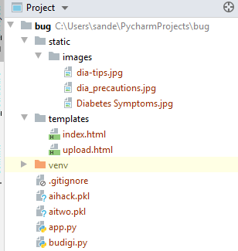

**Value entries by the user**

In the terminal below run the command: **python app.py**

An url will be displayed. By clicking on the url, it will redirect to the browser showing the front end.

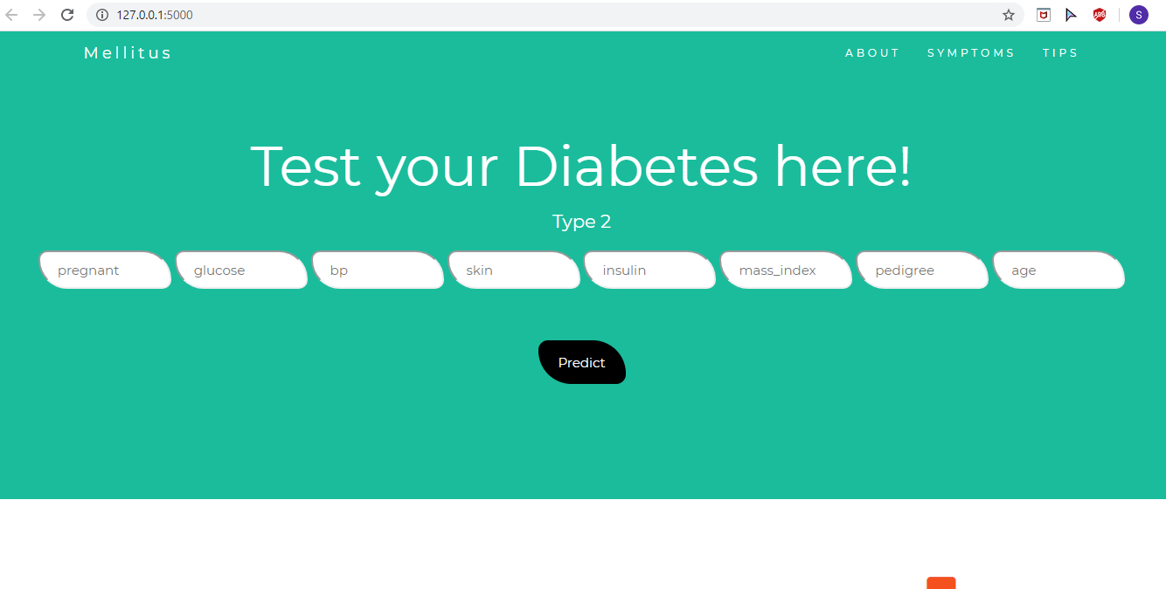

Enter the values of all the attributes and then click predict. The result will be displayed at the bottom of the predict button.

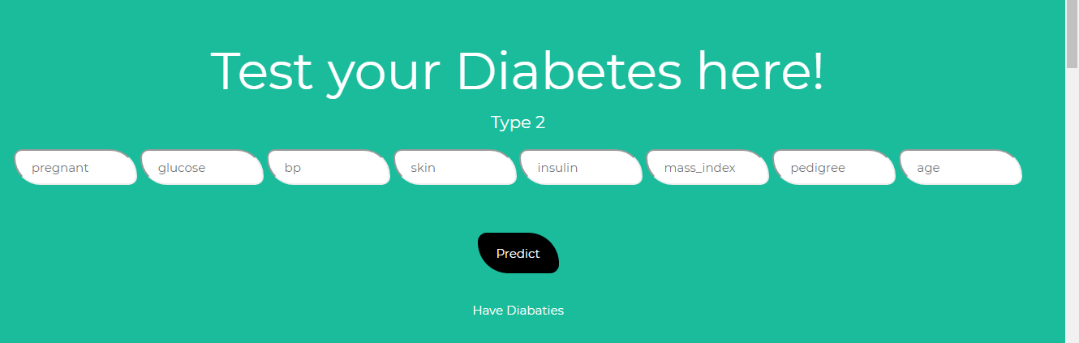

In the above figure I got the result as positive(Have Diabetes) in white color.

**CSV file**

The csv file frontend page is located in the url

“<http://127.0.0.1:5000/upload> ”. A page will be displayed as follows

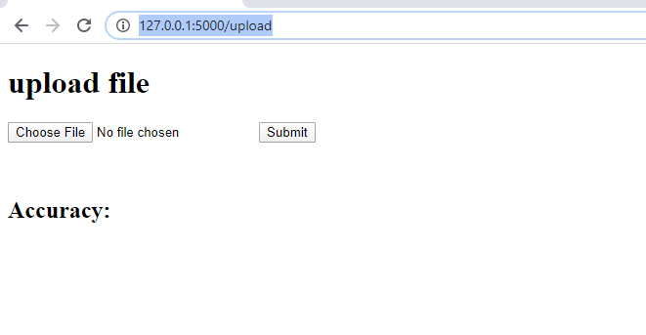

Choose the file from the computer and click submit.

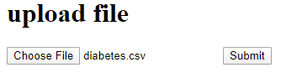

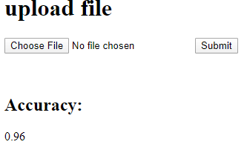

The accuracy is displayed.